Lifesum Food Diary Application

5 million downloads

4.4 Rating (120,888)

Health and fitness

Editor's choice (google play store)

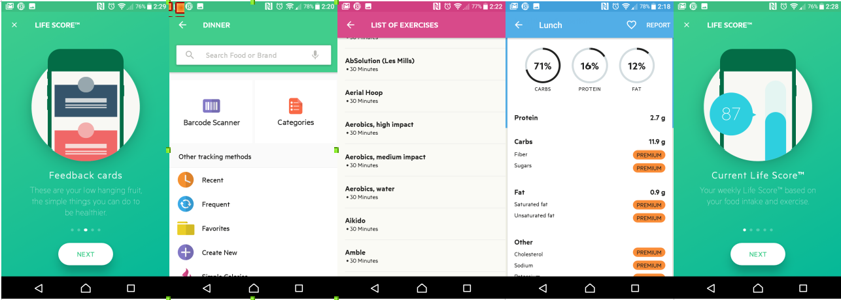

life sum keeps track of everything a user eats throughout the day. I does this by separating the breakfast, lunch, dinner and snacks. It keeps track by showing how many kcalories a user has left for that day. It even breaks down how much carbs, protein and fat the user should be eating each day.

Each category (breakfast, lunch...) has a multitude of tracking options :

1. Search bar
2. Categories :
   1. Beef
   2. Drinks
   3. Lamb
   4. Food cupboard

Above is a small sample of the range the application offers.

1. History allows the user to see watch over time what they would eat frequently or recently.
2. Favorites this option allows user to enter favorite meals, recipes and foods

Lifesum also allows the user to monitor how much water they are drinking and how much they should be drinking.

The application uses a incorporated barcode scanner which allows users to scan the barcode of snacks and other food as they are shopping.

There is also a social side to the application which gives tips and inspirational content that users of the application can comment and put up their own thoughts.

The application also has a questionnaire that sums up your life score (based on weight, height and eating habits). The score then displays the result as a chart

Good :

* Kcal shows how many calories left for a day
* Water monitor
* Barcode scanner
* Provides recommendations
* Social aspects
* Application can sync with other fitness applications such as fitbit and google fit

Bad :

* The shear amount of choice for each meal

Lifesum is a well rounded food diary application. The key points that I will take from it are how it interacts with other applications, the barcode scanner and the calories left for a day.

Dining Note

50 million downloads

4.6 (1397)

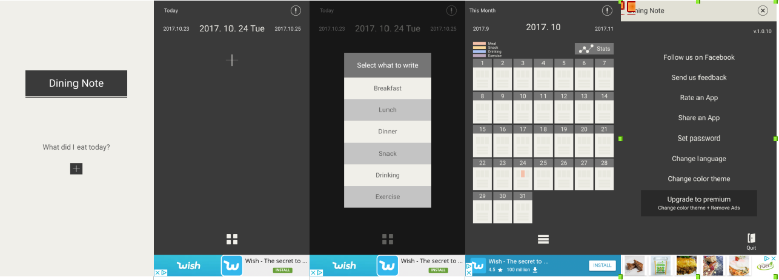

Dining Note starts up up with a blank note asking what you eating today. It then allows the user to select which meal they will be entering. Then it prompts the user to enter manually the information on that meal.

Type:

1. Breakfast
   1. Enter your meal

Once entered the application will allow the user to view what previous meals they have had in the form of a calendar with different colours for each different food group, and the stats for all of the meals.

Good :

* Simple interface to use
* Straight to the point only a food diary
* The use of the calendar to show meals

Bad :

* Not free version ads constantly appear
* Stats could be better
* Entering the data for each meal is time consuming

The application provides a simplistic way to keeping track of meals. The calendar for keeping track of meals was very interesting.

Food Diary

I Million Downloads

3.9 (3641)

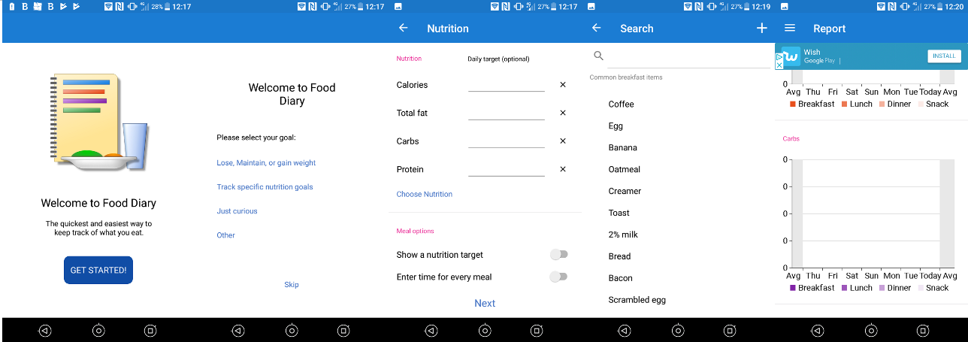

Food Diary like many other applications of its kind prompts the user for what they actually want to achieve from the application under the following headings

* Lose, maintain, or gain weight
* Track specific nutrition goals
* Just curious
* Other

Once you select one of the following or select other you are then brought a goal page. It allows the user then to input their goals such as

* Date
* Calories
* Total fat
* Carbs
* Protein

Once this information has been inputted its asks the user to enable the application to send reminders for each meal.

The layout of the home page is simple with four main menu heads breakfast, lunch, dinner and snacks. The top has a menu bar displaying today, journal, reports showing a user's progress using a graphical display, my recipes and goals.

Good :

* Asking user what they will be using the application for
* Setting up reminders for each meal
* The way it allows to select foods from a list but also make a note on that food when selecting it.

Bad :

* It contains ads
* Could use some more functionality such as an advice section or a barcode scanner.

One of the best things I noted about this application was that everything that a food diary should be was all listed on one page all of the meals and the input for the meals was straightforward and allows the user to input their own notes on the specific meal they are having.

Motion tracking applications

Fitbit

10 million downloads

4.0 (302, 593)

Editors choice

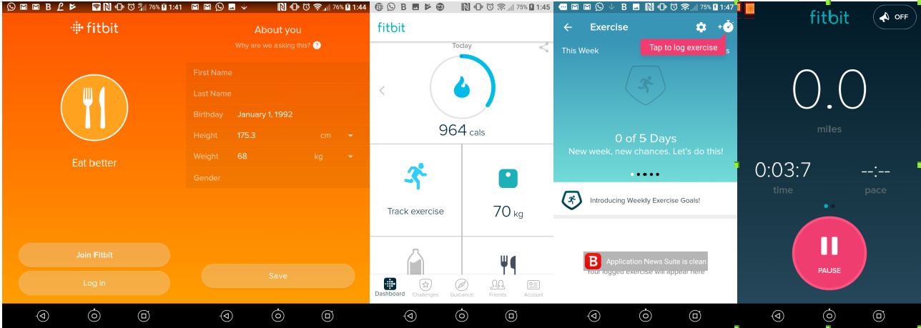

Fitbit primarily a fitness tracking application using motion to track the user. Its uses a mobile's range of sensors at the basic level but it's there wearable technologies that really gives this application an edge over the other ones allowing more specific sensors built for the application. They include :

* Swim
* Steps
* Sleep
* ...

The fitbits sensors are able to distinguish between walking and light exercise to if you are playing a sport or more demanding exercise.

Fitbits home screen is kept quite simple with steps, miles and calories and then four squares to track exercise, weight, water intake and what you have eaten today. The footer bar then holds dashboard, challenges, guidance, friends, account.

Good :

* The account setup
* The layout of the application
* The sensor features

Bad :

* Needs a fitbit

Overall Fitbit is a well polished application that works well for tracking fitness but what I will take from this is how external pieces of technologies can improve the application.

Google Fit

10 million downloads

3.9 (231,346)

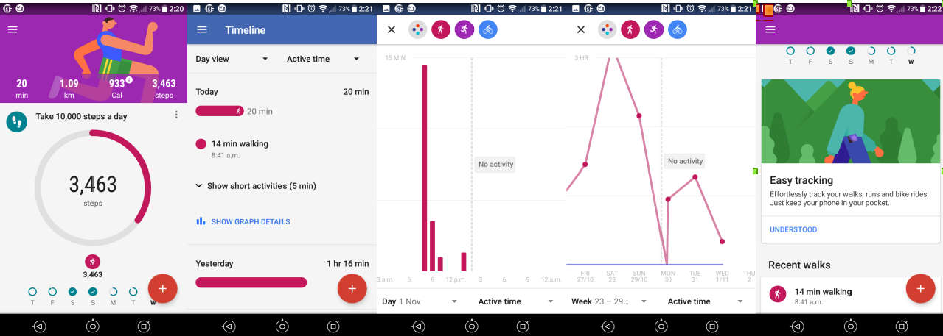

Google fit is quick to set up and once a user has setup an account. The application can be left running in the background and will track a user's movement. There are a range of different option that can be used with google fit such as :

* How many steps should be taken each day
* Timeline of activity
* Add activity
* Log a user's weight
* Add goal

Google Fit can run completely without any user input apart from when they initially setup the application. The main focus on the applications homepage is the step counter everything revolves around it and as a fitness application it makes it easy to read and use.

Good :

* Runs autonomously
* Can connect with different applications

Google Fit does everything a basic fitness application needs to do backed up by google's powerful analytics engine it is a power application and the option of using it with other applications already on the market makes it a very adaptable application.

Runtastic

10 million downloads

4.5 (773,024)

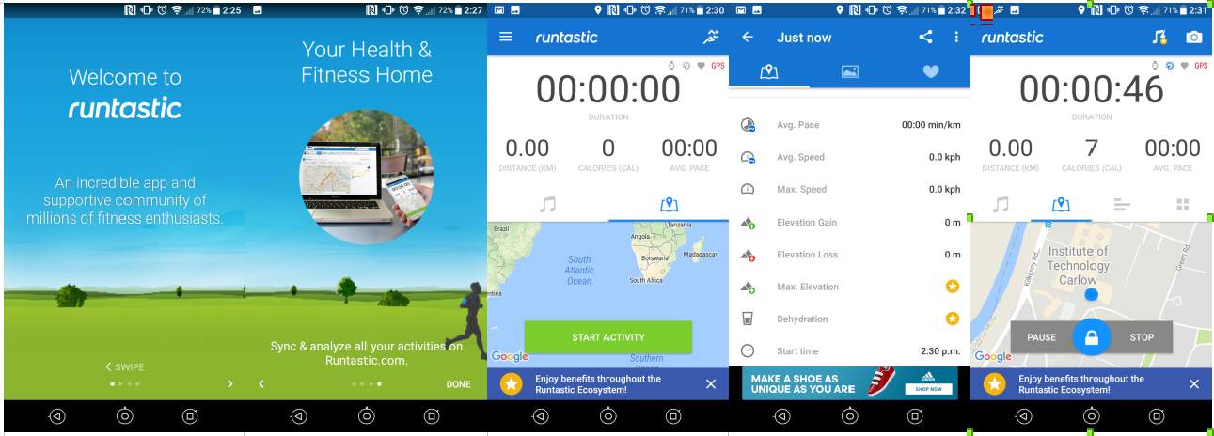

Runtastic is running application that uses GPS to track a runner on a specific track. The application is developed with runners in mind it. It can monitor the following :

* Distance km
* Calories
* Average pace
* Duration
* Speed
* Average Speed
* Dehydration
* Elevation
* Elevation gain
* Elevation loss
* Clock

The application relies heavily on GPS signal and a lot of the above mentioned cannot function without it. Only the most basic parts of the application functions. The application also has a heart rate monitor built in but it relies on wearable smart technology to work.

Good :

* The range it offers runners

Bad :

* GPS (In my case there was no GPS available)
* AD’s
* Needs extra bits to use all the applications functionality

Runtastic was an interesting application it got a lot of things right by using GPS but on the other because it relies on this technology and when it is not available the application loses what makes it stand out. I have learned that I will have to think carefully about using GPS